
Year 7 Integers and Data Mini Test Version 2
/47
Name: Date:
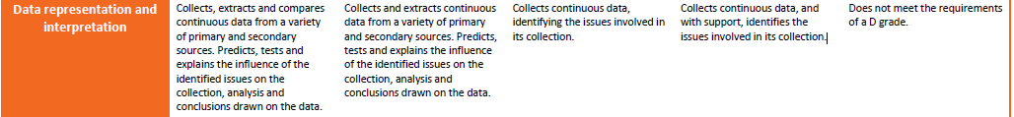
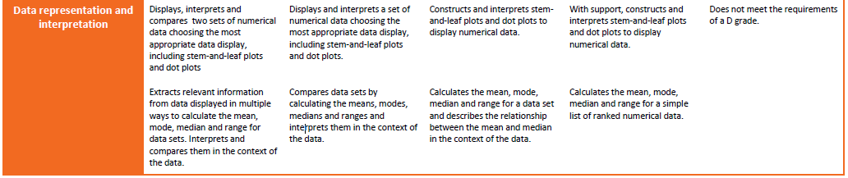
1 calculator and 1 A4 page of handwritten notes is allowed
Question 1 (5 marks)

Draw a line to connect the word to its correct meaning

Mean Most common number

Median The average

Range Data is much smaller or larger than most of the other data

Outlier Difference between largest and lowest

Mode Middle number of ordered data

Question 2 (3 marks)
Answer the following questions using the data below
2, 2, 5, 7, 13, 15, 15, 15, 18, 20

Determine the range ___________________ Determine the mode _____________________
Determine the median __________________
A class of students have tested their best reaction times and the following results were obtained.
Question 3 (4 marks)
8, 10, 13, 14, 17, 19, 19, 23, 24, 28, 30, 35.
Put this data into an ordered stem and leaf below. (4 marks)

Stem | Leaf
0

1

2

3

Key: 2|3 = 23
Question 4 (4 marks)
The stem and leaf plot below is the test results for a class on the end of chapter test.

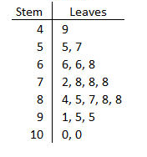
Find the following information:

Median ____________

Mode ____________

Range ____________

Mean ____________

Question 5 (6 marks)
A maths class recorded how many siblings they had. The results were;

0, 0, 1, 2, 2, 2, 2, 2, 2, 3, 3, 3, 3, 4, 4, 4, 5, 5, 6.
Use the line below to create a Dot Plot of this data. (4 marks)

0 1 2 3 4 5 6

What is the least common number of siblings? (1 mark)?

What is the most common number of siblings? (1 mark)?

Question 6 3 marks

Place the following numbers on the number line:

-2, 6, -6, 3, 1, -1

0

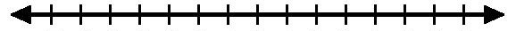

Question 7 4 marks

Circle the highest number and underline the lowest number

- -6 -4 9 -12 2

- 0 15 -2 -21 19

Question 8 (6 marks)
Place either a < or > in between each set of numbers:

- -7 ___ -12 b) -5 ___ 4

c) -3 ___ 0 d) 0 ___ 7

e) -12 ___ -23 f) -16 ___ -15

Question 9 4 marks

Complete the following (use your number line) :
- -5 - 2 = __________

- - 8 - 3 = __________

  - 2 - 3 = __________

  - -12 + 11 = __________

Question 10 (2 marks)

Susan had $48 in the bank. She wants to buy a pair of shoes for $65. How much extra does she need?

Question 11 6 marks
Use the graph below to answer the following questions.
A
●
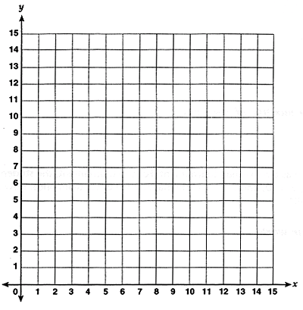
E
●
B
●
C
●
D
●

- The Coordinates for point A are ( 8, 11) . Write the coordinates for B, C, D & E.

B ______ C ______

D ______ E ______

- Plot the following coordinates on the graph above.

F (5, 4) G (2, 14)

End of test

